Summary of “SCNN…”

This paper designs a dataflow and an efficient hardware architecture that can efficiently handle sparse CNNs. The main idea is to skip the case of zero multiplication in weight and activation. In order to achieve the effect of speeding up and reducing power consumption.

The dataflow this paper proposed is called PT-IS-CP-sparse (PlanarTiled-InputStationary-CartesianProduct-sparse). It handles dataflow in two modes, dense and sparse. For the detail of this dataflow, please refer to the original paper.

The architecture of SCNN is below:

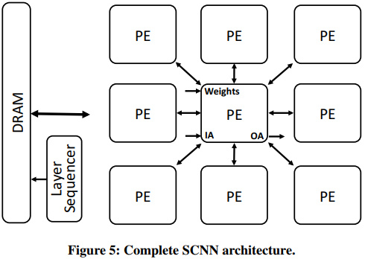

As shown in the figure above, the accelerator contains a set of simple interconnected PE arrays. Each PE receives the weight and activation of multiple channels and outputs the output of multiple channels. Adjacent 8 PEs are interconnected to exchange the halo values. (For detail of halo values, please refer to the original paper.)

The overall data flow control is orchestrated by the layer sequencer, which controls a DRAM controller for broadcasting weight to all PEs, and activation can flow in or out.

Combine the proposed data flow, SCNN facilitates efficient delivery of those weights and activations to a multiplier array, where they are extensively reused; product accumulation is performed in a novel accumulator array. On contemporary neural networks, SCNN can improve both performance and energy by a factor of 2.7x and 2.3x, respectively, over a comparably provisioned dense CNN accelerator.